IPC Display Layout Selection Control Function – CGEA 1.3 – S550 Specific

Functional Description

This STSS describes the selection of the IPC Display Layout. This STSS is applicable when the cluster has more than one display layout. The IPC Display Layout Menu consists of a list of IPC Display Layouts that can be selected by the vehicle occupant. Once an IPC Display Layout Menu item is selected, the cluster display will be updated to the selected IPC Display Layout.

The IPC Display Layout Menu can vary from program to program and a program specific IPC Display Layout Menu List will be specified in a program specific IPC Menu Structure file. Each IPC Display Layout Item will have an associated graphic layout specified in a program specific Wallpaper file. One IPC Display Layout item will be designated the battery connect default and it will be assigned IPC_Dsply_Layout value of 0x0. The selected IPC Display Layout will be retained during a Key Cycle.

Interfaces

Interface Context Diagram (I/O Block Diagram)
- IPC Display Layout Selection Control Function Context Diagram
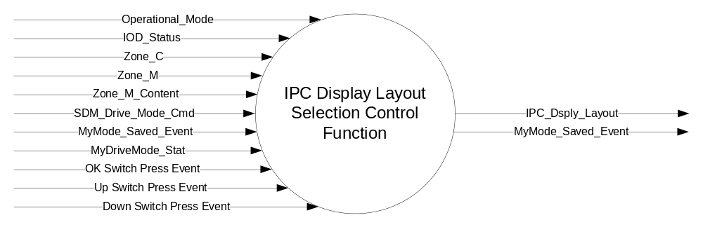

Inputs

- INTERNAL:
- Operational_Mode
- OK Switch Press Event
- Up Switch Press Event
- Down Switch Press Event
- Zone_C
- Zone_M
- Zone_M_Content
- SDM_Drive_Mode_Cmd
- MyMode_Saved_Event
- MyDriveMode_Stat
- IOD_Status

Outputs
- IPC_Dsply_Layout, variable to identify the currently selected IPC Display Layout
- MyMode_Saved_Event

Function/Performance

Operational Modes

Mode | Differentiating Vehicle Conditions
Sleep Mode | IPC Display Layout Selection Control Function Disabled
Limiting Mode | IPC Display Layout Selection Control Function Disabled
Normal Mode | IPC Display Layout Selection Control Function Enabled / Disabled
Crank Mode | IPC Display Layout Selection Control Function Enabled / Disabled

Voltage Levels

Refer to the Cluster Features table located in the Operational Modes and Voltage Range Strategies Section in this SPSS.

Human-Machine Interface

Visual

Indicator Graphics / Display Format
Refer to “<Program> Cluster Menu Structure.xls”.
This is an example of a layout from a program specific Menu Structure file.

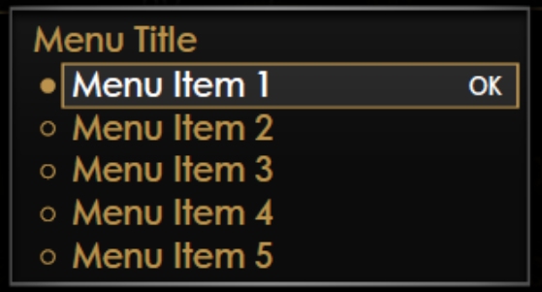

menu level 3 | menu level 4 |  | additional information
Cluster Appearance | title: Cluster Appearance
 |  Change with Drive Mode | Appearance is set according to current drive mode | default setting
 |  Normal | Appearance changes to and stays in Normal
 |  Sport | Appearance changes to and stays in Sport
 |  Track | Appearance changes to and stays in Track

Indicator Color Coordinates

Reference Ford HMI or Studio Wallpaper files for the specific program.

Indicator Characteristics

Reference Ford HMI or Studio Wallpaper files for the specific program.

Audio

None

Switch Control Logic

Consumer access to the IPC Display Layout Selection Control Function shall be as specified in the message center basic functionality display as specified in Message Center STSS. The Switch logic while the IPC Display Layout Menu is the active display is also in this STSS.

System Accuracy

Within a 100msec of receiving a message that results in a change of state the cluster will update the display to the proper status.

Operation: Performance and Functional

Subsystem Algorithm Flowchart / State Diagram
- IPC Display Layout Selection Control Function Flowchart
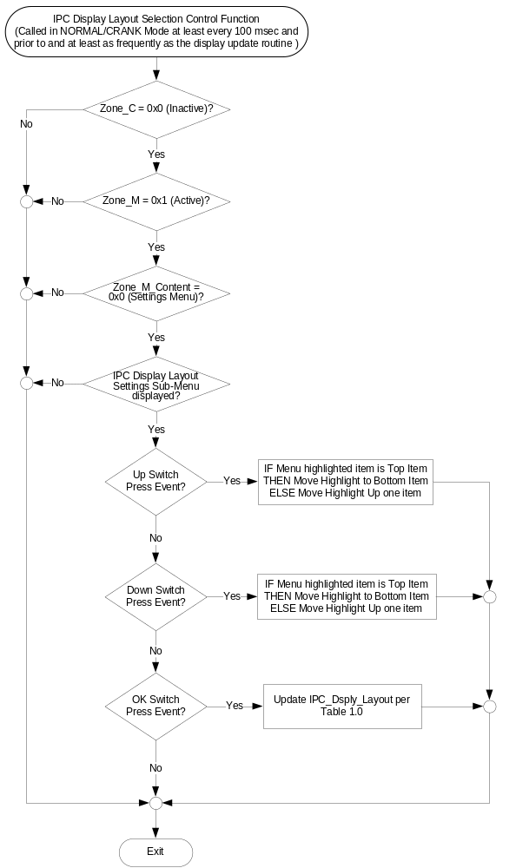
- Cluster Appearance menu and IPC_Dsply_Layout
M/C_Display_Status = Cluster Appearance | 5-Button Switch  Selection Event | M/C_Display_Status = Cluster Appearance | IPC_Dsply_Layout | Permanent_  Appearance_Flag
Cluster Appearance   Change with Drive Mode   Normal   Sport   Track | Up/Down + OK  (Select Normal) | Cluster Appearance   Change with Drive Mode   Normal   Sport   Track | Normal (0x0) | Normal (0x0)
Cluster Appearance   Change with Drive Mode   Normal   Sport   Track | Up/Down + OK  (Select Sport) | Cluster Appearance   Change with Drive Mode   Normal   Sport   Track | Sport (0x1) | Sport (0x1)
Cluster Appearance   Change with Drive Mode   Normal   Sport   Track | Up/Down + OK  (Select Track) | Cluster Appearance   Change with Drive Mode   Normal   Sport   Track | Track (0x2) | Track (0x2)
Cluster Appearance   Change with Drive Mode   Normal   Sport   Track | Up/Down + OK  (Select Change with Drive Mode) | Cluster Appearance   Change with Drive Mode   Normal   Sport   Track | SDM_Appearance  Per Table 1.1 | SDM (0x3)
Note: Text in this table is for example purposes. Refer to “<Program> Cluster Menu Structure.xls” and Program VAPS Model for program specific text.

- SDM_Appearance based on SDM_Drive_Mode_Cmd
SDM_Drive_Mode_Cmd | SDM_Appearance
Normal (0x0) | Normal (0x0)
Snow/Wet (0x1) | Normal (0x0)
Sport+ (0x2) | Sport (0x1)
Track (0x3) | Track (0x2)
Drag (0x4) | Track (0x2)
MyDriveMode (0x5) | MyDriveMode_Appearance Per Table 1.2
Sport (0xF) | Normal (0x0)
- MyDriveMode_Appearance and MyMode_Saved_Event based on MyDriveMode_Stat
MyMode_  Saved_Event | Permanent_  Appearance_Flag | MyDriveMode_Stat | MyDriveMode_Appearance | MyMode_  Saved_Event
0x1 (True) | SDM (0x3) | Normal (0x0) | Normal (0x0) | 0x0 (False)
0x1 (True) | SDM (0x3) | Snow/Wet (0x1) | Normal (0x0) | 0x0 (False)
0x1 (True) | SDM (0x3) | Sport+ (0x2) | Sport (0x1) | 0x0 (False)
0x1 (True) | SDM (0x3) | Track (0x3) | Track (0x2) | 0x0 (False)
0x1 (True) | SDM (0x3) | Drag (0x4) | Track (0x2) | 0x0 (False)
0x1 (True) | SDM (0x3) | Sport (0xF) | Normal (0x0) | 0x0 (False)
0x1 (True) | ! SDM (0x3) | X | Permanent_Appearance_Flag | 0x0 (False)

- IPC Display Layout based on IOD_Status
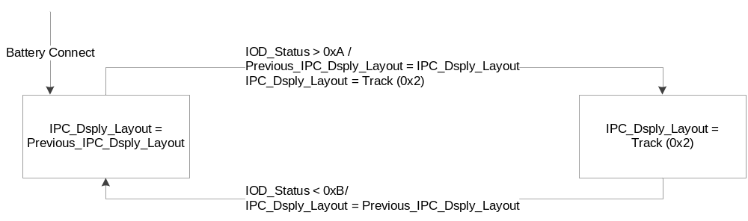

Operation Description (supports algorithm flowchart /state diagram)

- When an IPC_Dsply_Layout Menu item is selected as specified in the IPC Display Layout Selection Control Function Flowchart, the selected IPC Display Layout is displayed. This is specified in the appropriate Message Center Display STSS.
- The MyDriveMode is based on the drive mode that was set when the MyDriveMode was saved. The MyDriveMode also possesses the default view of this drive mode. If the drive mode is changed to the MyDriveMode, the view changes accordingly as long as the Cluster View is set to “Change with Drive Mode”. If the Cluster View is set to a permanent view, the MyDrive-Mode also does not change this view. If the MyDriveMode is saved while the Cluster view is set to a permanent view, this view will be saved with the MyDriveMode, not the default view of the current drive mode.
If the MyDriveMode is saved while the Cluster view is set to a permanent view, this view will be saved with the MyDriveMode, not the default view of the current drive mode.
- The Status Screen Information Display – S550 Only – CGEA1.3 STSS sets MyMode_Saved_Event = 0x1 (True) when MyDriveMode is saved. When MyMode_Saved_Event → 0x1 (True), this STSS will set MyDriveMode_Appearance based on DriveMode and set MyMode_Saved_Event = 0x0 (False).
- After choosing a Track App (except for the Performance Shift Indicator) from the menu, the cluster will change into Track view. After the view has switched to the Track App, the first step of the selected Track App is shown in the IoD area, as indicated by the state of IOD_Status. After the action of the Track App is completed, the view goes back to its original state.

Function Safety Classification (EMC)

Class B

Memory Storage

Parameter Name | Description | Value at  Battery Connect | Value at Module Wake-up
Down Switch Press Event | Event that is indicated as per the switch interface for the Message Center *. | See 2 below | See 2 below
IOD_Status | State Indicator to identify which Info On Demand Display should be currently Active | 0x0 (No Info Display) | Do Not Init
IPC_Dsply_Layout | State Indicator to identify which IPC Display Layout should be currently Active  Normal (0x0)  Sport (0x1)  Track (0x2) | Normal (0x0) | Do Not Init
MyDriveMode_Appearance | Appearance accociated with MyDriveMode. This value is equivalent to the Appearance of the DriveMode that was Active when MyDriveMode was created.  Normal (0x0)  Sport (0x1)  Track (0x2) | Normal (0x0) | Do Not Init
MyDriveMode_Stat | Active DriveMode when MyDriveMode was created.  Normal (0x0)  Snow/Wet (0x1)  Sport+ (0x2)  Track (0x3)  Drag (0x4)  Sport (0xF) | Normal (0x0) | Do Not Init
MyMode_Saved_Event | Flag set when MyDriveMode is created. This flag is set to True in the Status Screen Information Display – S550 Only – CGEA1.3 STSS when MyDriveMode is created and set to False in this STSS when MyDriveMode_Appearance is saved.  0x0 (False)  0x1 (True) | 0x0 (False) | 0x0 (False)
OK Switch Press Event | Event that is indicated as per the switch interface for the Message Center *. | See 2 below | See 2 below
Operational_Mode | 4 state indicator for cluster operational mode | Limited | Limited, Normal or Crank
Permanent_Appearance_Flag | Flag used to determine if MyDriveMode is saved while the Cluster view is set to a permanent view.  Normal (0x0)  Sport (0x1)  Track (0x2)  SDM (0x3) | Normal (0x0) | Do Not Init
Previous_IPC_Dsply_Layout | Value of IPC_Dsply_Layout before entering certain states of Track Apps. The IPC will return the Appearance to this value when the Pony Mode is exited.  Normal (0x0)  Sport (0x1)  Track (0x2) | Normal (0x0) | Do Not Init
SDM_Appearance | Appearance tied to the current SDM.  Normal (0x0)  Sport (0x1)  Track (0x2) | Normal (0x0) | Do Not Init
SDM_Drive_Mode_Cmd | Command from IPC to indicate state of SDM.  Normal (0x0)  Snow/Wet (0x1)  Sport+ (0x2)  Track (0x3)  Drag (0x4)  MyDriveMode (0x5)  Sport (0xF) | Normal (0x0) | Do Not Init
Up Switch Press Event | Event that is indicated as per the switch interface for the Message Center *. | See 2 below | See 2 below
Zone_C | State indicator to identify if Zone C is currently being displayed (Active = 0x1). | See 1 below | See 1 below
Zone_M | State indicator to identify if Zone M is currently being displayed (Active = 0x1). | See 1 below | See 1 below
Zone_M_Content | State Indicator to identify which display is currently active in Zone M. | See 1 below | See 1 below
1 Refer to the appropriate Message Center Display STSS.
2 Refer to appropriate Message Center Switch Interface STSS.

Reconfigurable Telltale

Not Applicable

Prove Out

Not applicable

Message Center Msg

Refer to text as defined in the Text Translation file.

Error Handling

No missing message strategy defined for these input signals.

Diagnostics

Self Test

None

Engineering Test Mode

None

Part II Performance

Supported Diagnostic Trouble Codes (DTCs) - None

DID DExx - None

Reference Specification
- Appropriate Message Center Display STSS
- Appropriate Message Center Switch STSS
- Appropriate Program Specific Text Translation File
- Appropriate Program Specific IPC Menu Structure File

Revision History
SPSS Module Revision History

Revision Level | Name | Change Description | Date
1.0 | J. Gregoire | Initial release.  This STSS is based on IPC Display Layout Selection Control Function - CGEA1.3_v1.0, but has been heavily updated to support the special functionality on S550. | 2/19/2016

